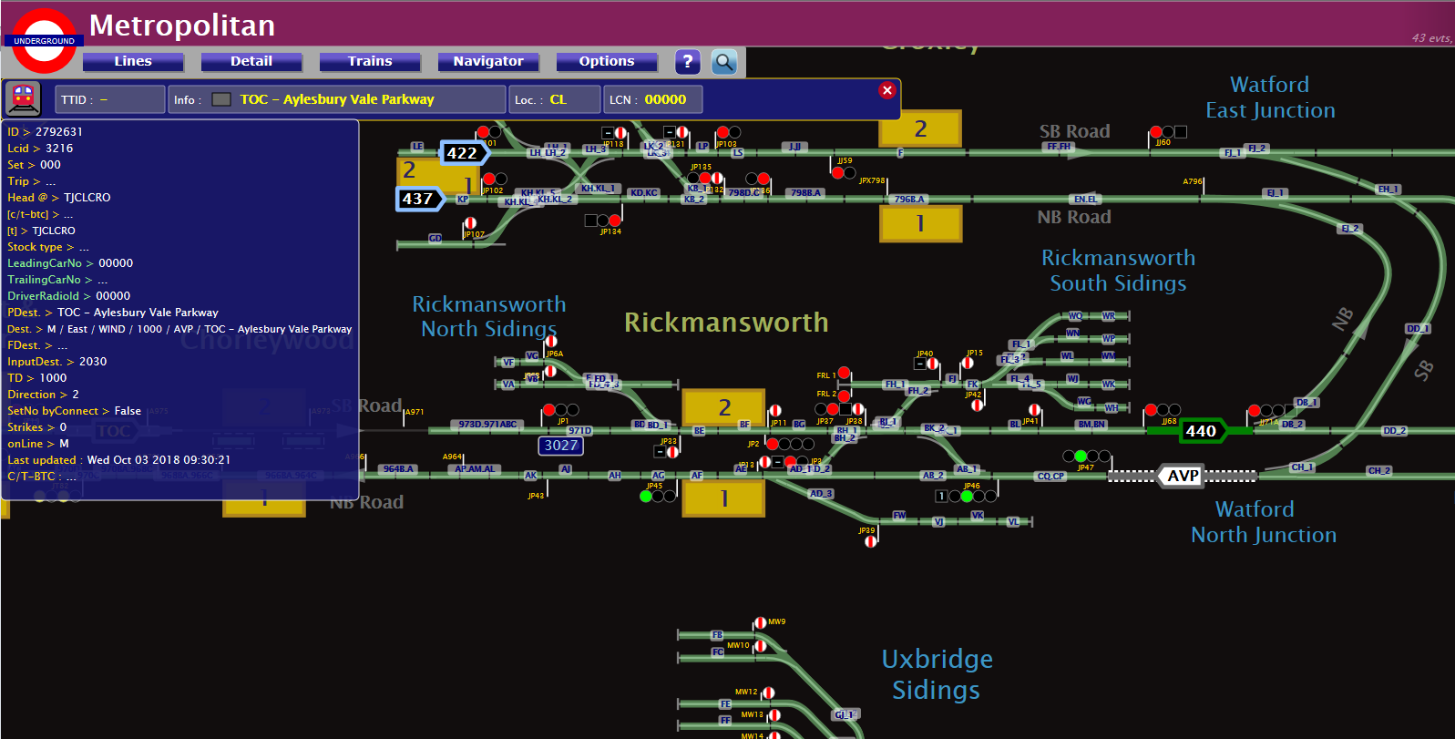
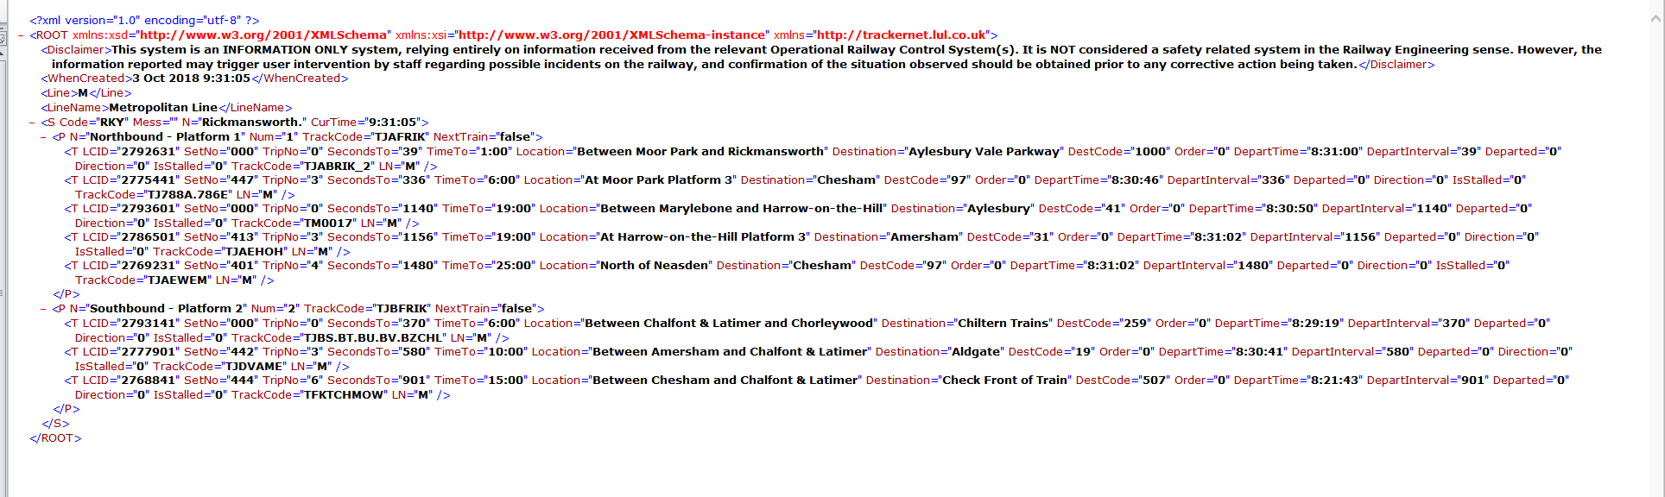
Fields outlined in Green needs the information to be swapped – i.e. ID on Trackernet should be moved to a new TrainID field on Trainlists and information from “Lcid” field on Trackernet should be added to LCID field on Trainlists..
TrainID

