Unified API Changes for Alternative Routes and Descriptions

We have made changes to the Journey Planner API to enable the following future changes:
- We are planning to include alternative routes in a journey plan response
- It will be possible to request different multi modal scenarios
- Multi modal journeys will include a description field to indicate the type of journey that has been returned.

Alternative routes
New parameter: includeAlternativeRoutes
We plan to add functionality to include alternative routes in a journey plan.
These journeys are calculated by taking the original routes that were generated and attempting to re-calculate them by removing some of the elements that the original route used.
For example, if the original journey included a leg on the Heathrow or Gatwick Express, then the process to calculate the alternative would try and plan the journey as if theses lines were not available.
Similar rules will apply for all other lines. Each rule is applied individually and once an alternative route is found later rules will be ignored.
Alternative routes will be flagged in the response with new response field entitled ‘alternativeRoute’. This will be true for an alternative route and false for standard routes.
By default, we will not include alternative routes in a response and so to receive alternative routes you will have to pass the ‘includeAlternativeRoutes’ parameter as true.
Example alternative journey request:
https://api.tfl.gov.uk/Journey/JourneyResults/940GZZLUHOH/to/940GZZLUBND?includeAlternativeRoutes=true
Partial alternative journey response:
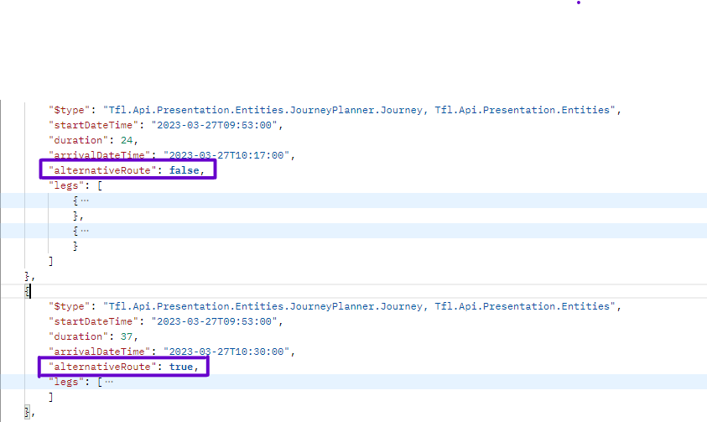

New multi modal scenarios
New parameter: overrideMultiModalScenario
When a journey plan request includes “useMultiModalCall=true” the journey planner engine runs a scenario that will try and generate 3 intermodal journeys, a bus only journey, a walking journey and both a cycle and cycle hire journey.
This is the default scenario, named Scenario1.
We are going to enable other scenarios to be chosen within a journey planner. These scenarios are listed below along with the journeys they will return:
Scenario | Journeys
1 | 3 x Intermodal  Bus only  Walking  Cycle  Cycle Hire
2 | 2 x Intermodal  Cycle  Cycle hire
3 | 3 x intermodal  Bus only  Cycle  Cycle Hire  Walk
4 | 3 x Intermodal  Step free  Step free to platform  Bus only  Walking  Cycling  Cycle Hire
5 | Bus only  Step free  Walking
6 | Bus only  Step free to platform  Walking

Journey planner will try and generate a journey for each of these journey types but there may be occasions where only some of them are possible.
If scenario 1 is required setting “useMultiModalCall=true” will be return this
If a different scenario is required, then you should still set “useMultiModalCall=true” but also provide the new parameter of “overrideMultiModalScenario” with its value set to the required scenario.
Example scenario 4 request:
https:// api.tfl.gov.uk/Journey/JourneyResults/940GZZLUUXB/to/940GZZLUBNK?useMultiModalCall=true&overrideMultimodalScenario=4

Descriptions

We have added a description field to the response for multi modal journey requests. This is to help identify the type of each journey without having to examine each leg.
The description will include the name of the multi modal scenario that was used and a description of the journey. For a scenario 1 response the description of the bus only journey will be: ‘Scenario1 Bus only’.

Descriptions will not be returned for non-multi modal requests.
Example multimodal response:

